IEA BESTEST Multi-Zone Modeler Report

TRNSYS 15 – TYPE 56

ADAM Christophe – ANDRE Philippe
Department of Environmental Sciences and Management – ARLON
GEORGES Bernard – LEBRUN Jean
Laboratory of Thermodynamics – LIEGE

University of Liège – Belgium

Tuesday, November 16, 2004

Introduction
TRNSYS[1] (“Transient System Simulation”) is a transient system simulation program with a modular structure. The modular nature of TRNSYS gives the program tremendous flexibility, and facilitates the addition to the program of mathematical models not included in the standard TRNSYS library. TRNSYS is well suited to detailed analyses of systems whose behavior is dependent on the passage of time.
The TRNSYS version is TRNSYS 15.300 developed by Solar Energy Laboratory (University of Wisconsin-Madison) in Madison, USA.
The building model used in this work is TYPE 56 developed by TRANSSOLAR Energietechnik GmbH in Stuttgart, GERMANY. The TYPE 56 version is the version which is included in the TRNSYS 15.300 version. TRNFLOW isn’t used.
The simulation time step is 1 hour.

Modeling Assumptions
In this chapter, we define two different formulations of the problems MZ200, MZ210, MZ300 and MZ310: simple and complex. With the simple formulation, it is supposed that there is only one adiabatic wall per zone. This wall is parallel to the common wall(s) and equal area. The other case is named “complex”. The geometry respects the specifications: 6 orthogonal walls per zone.

Theorical formulation of the two zone problem with 1 adiabatic wall per zone (2 walls per zone)(Simple formulation)
First of all, we have recalculated the theorical solution of the two zone problem with two walls per zone. In this configuration, we consider that all the surfaces are parallel and equal area. In Figure 1, the problem is represented by a network with nodes and resistances. The resistances of the walls (conduction) (R₀₁, R₂₃ and R₄₅) are drawn in blue; the resistances of heat transfer by air convection (R_{1a}, R_{2a}, R_{3b} and R_{4b}) in green and the resistances of heat transfer by radiation (R₁₂ and R₃₄) in brown.
The problem is defined like this:
- Conduction in adiabatic walls: 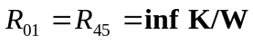
where inf is an infinite value (∞).
- Conduction in common wall: 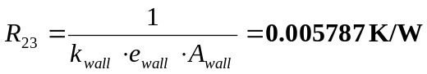
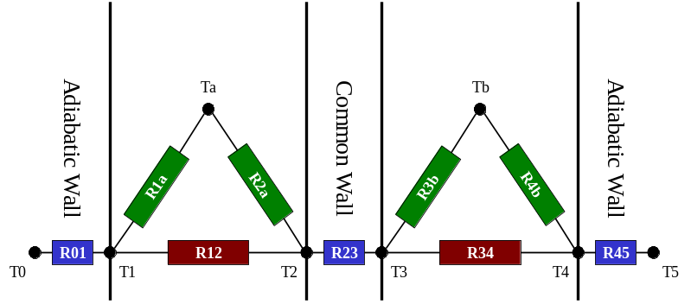
Figure 1 - Two zone problem
- Convection: 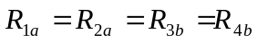
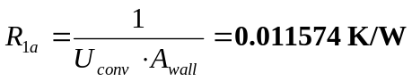
- Radiation: 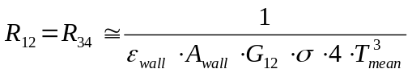
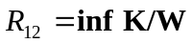 if ε_{wall}=0
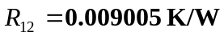♣ if ε_{wall}=0.9
where G_{ij} is the view factor between the surfaces i and j
In this definition of the radiation heat transfer coefficient, it is supposed that all surfaces are parallel and equal area. In those conditions, the view factor is equal to 1.
- T_{a} and T_{b} are fixed to 25°C and 15°C as defined in the specifications. The internal gains are fixed to 1000 W in each zone.
In TRNSYS Type 56, the problem is reduce to a star network problem more easy to solve (see Figure 2). A Y-Δ transformation is performed. In this simplification, some new resistances are defined:
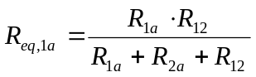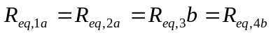
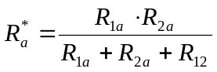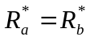
Two new nodes♠ appear in this configuration: T_{a}* and T_{b}* (Figure 2).
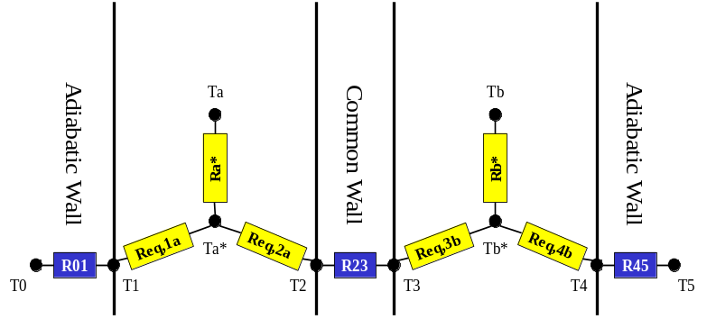
Figure 2 - Simplification of the two zone problem

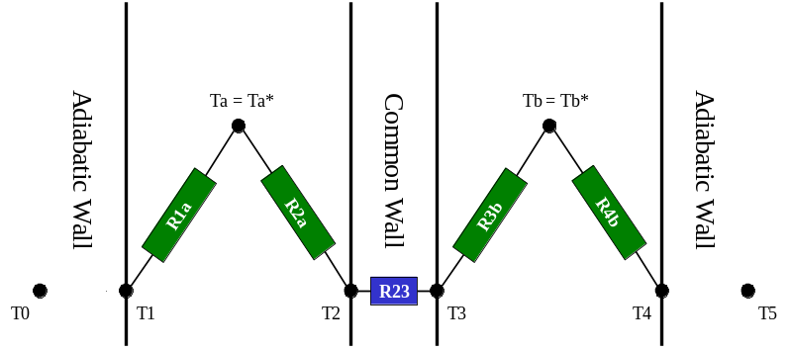
Figure 3 - Simplification of the MZ200 problem

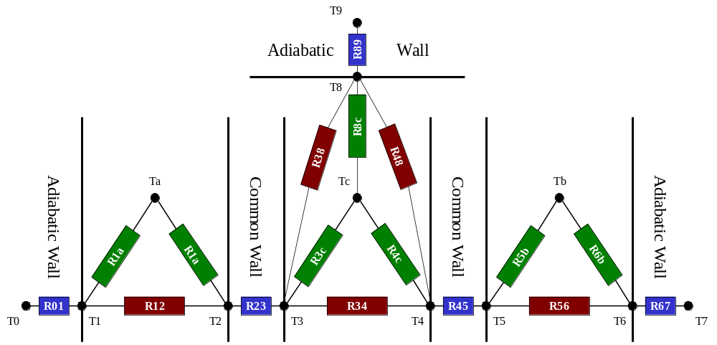
Figure 4 - Three zone problem

MZ200 (ε_{wall}=0)
In this case, R_{a}* is equal to zero. R₁₂ is infinite and R_{eq,1a} is not well defined. The determination of R_{eq,1a} is difficult because in this case R₁₂ is infinite. But, if we calculate the inverse of the analytical expression, we have:
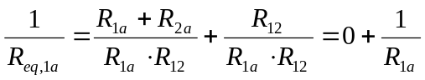
then
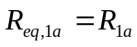
The star network can be redrawn (see Figure 3). The solution obtained with this “Y-Δ” method is the same as the solution in the specification document (analytical solution):
Qa = 654.4 W Qb = 1345.6 W
T2 = 21°C T3 = 19°C
U = 1.6 W/K.m² UA = 34.56 W/K

MZ210 (ε_{wall}=0.9)
Now, we calculate the equivalent resistances and we have:
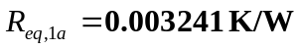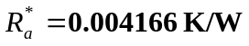
The problem becomes a simple problem with 5 resistances in series (R_{a}* - R_{eq,1a} – R₂₃ – R_{eq,1a} – R_{a}*). The exact solution is in this case (“Y-Δ” method):
Qa = 514.62 W Qb = 1485.38 W
Ta* = 22.98 °C T2 = 21.4 °C
T3 = 18.6 °C Tb* = 17.02 °C
U = 2.25 W/K.m² UA = 48.54 W/K

Theorical formulation of the three zone problem with 1 adiabatic wall per zone (2 walls for A and B zones, 3 walls for zone C)(Simple formulation)
The problem is presented in Figure 4.
The zones A and B are the same zone as the previous problem. The new middle zone (C) is a three wall zone. Only one adiabatic wall is supposed. Its area is equal to the common wall area. It is also supposed that the three walls are parallel and equal area. It needs three convective resistance and three radiative resistances to be defined:
- Conduction in adiabatic walls: 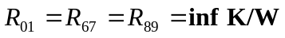
- Conduction in common wall: 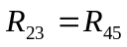
- Convection: 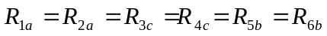
- Radiation: 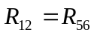
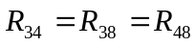
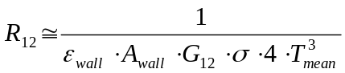
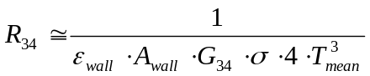
if ε_{wall}=0
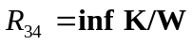
if ε_{wall}=0.9
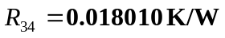
The same assumption is made as before: It is supposed that all surfaces are parallel and have the same area. We make the same assumption than the assumption done in the TYPE 56 software [3]. We consider that the view factor of the absorption surface is the ratio between the area of the radiative surface which is considered and the sum of areas of all the other radiative surfaces. Thus, the view factors for the zone C are equal to G₃₄=0.5 (Zones A and B: G₁₂=1).
- T_{a} and T_{b} are fixed to 25°C and 15°C as defined in the specifications. The internal gains equal to 1000 W for the A and B zones and equal to 864 W for the C zone.
It is necessary to simplify the problem to find the theorical solution. The same Y-Δ transformation is performed. The A and B zones are simplified and the equivalent resistances are calculated as in the previous problem.
The simplification of the three-zone model needs to make difference between both cases: ε_{wall}=0 and ε_{wall}=0.9.

MZ300 (ε_{wall}=0)
With an emittance equal to zero, the problem becomes simple. It is defined by six resistances in series (R1a – R23 – R1a – R1a – R23 – R1a).
The solution is the same as the solution in the specification document:
Qa = 1259.2 W Qb = 1604.8 W
T2 = 27 °C T3 = 28.5 °C
T4 = 25.5 °C T5 = 22 °C
Tc = 32.5 °C
U = 1.6 W/K.m² UA = 34.56 W/K

MZ310 (ε_{wall}=0.9)
The following step-by-step procedure, which was proposed by Seem[3], is used to calculate the resistances in the star network (see Figure 5) from the resistances defined in the non simplified problem (view factor network in Figure 4):
- Determination of the resistances between nodes in the view factor network when others are floating. The energy balance in performed on each node. Then, the problem formulation is written into a matrix formulation.
- Determination of the resistance between the star node and the air node (Minimization of the square dimensionless form of the error in resistance between all nodes with respect to the resistance between the star and air nodes.).
- Determination of the resistances between the surface nodes and the star node (The net heat flow to the air between enclosures surfaces and the air is the same for the star network and the view factor network).
We apply the propose method to reach the theorical solution. In a MatLab file (see Annex), we have computed the solution:
Qa = 1186.8 W Qb = 1677.2 W
T2 = 26.99 °C T3 = 28.07 °C
T4 = 26.13 °C T5 = 22.21 °C
Ta* = 25.786 °C Tb* = 17.82 °C
Tc = 31.00 °C
U_{AC} = 1.44 W/K.m² UA_{AC} = 31.11 W/K
U_{BC} = 1.96 W/K.m² UA_{BC} = 42.32 W/K
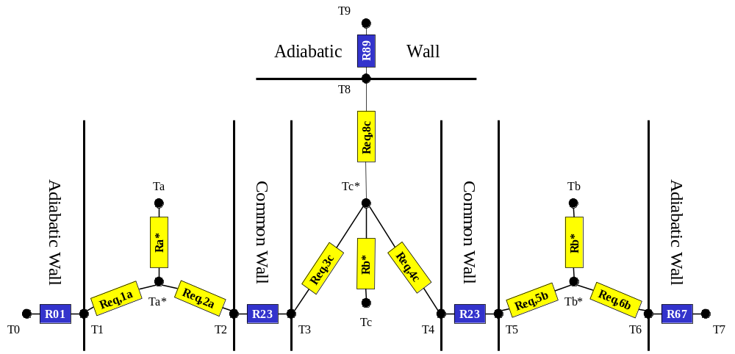
Figure 5 - Simplification of the three zone problem

Theorical formulation of the problems with 6 walls per zone (Complex formulation)
With TYPE 56, it is impossible to define the real geometry of the zones. The user can only introduce the area of the surfaces. The software needs to know moreover the distance and the angle between two wall to calculate the view factor. TYPE 56 calculates the view factors according to the assumption explained in the 2.2 paragraph.
It is possible to evaluate a theorical solution to those problems but it needs more time. Moreover, we don’t need a complex problem to evaluate the performances of the TYPE 56. First, we will compare the results of the simulations and the theorical solutions of the simple formulations of the problem (1 adiabatic wall per zone). Next, we will produce simulation results of the more complex formulation (6 walls per zone). Those results will be used to realize a global comparison between different softwares.

Modeling Options
We have defined the multi-zone model with 3 walls (MZ200 - MZ210) or with 5 walls (MZ300 - MZ310). The common walls were defined as massive walls. All the adiabatic walls were defined as massiveless walls, one wall per zone (the adiabatic wall surface is equal to the common wall surface). The back surface temperature was imposed as the same as the front surface temperature of the associated wall.
The ambient conditions do not influence the multi-zone conditions. So, the weather file wasn’t used.
TYPE 56 needs some parameters to simulate the building. Some of them are physical parameters such as density or specific heat of air, Stefan-Boltzmann Constant or average mean surface temperature. The model fixes also the emittance to 1 for walls. In order to model the effects of a variation of the wall emittance, we imagine this following manipulation of the parameters.
The total hemispherical emissive power (blackbody radiation) is calculated by the Stefan-Boltzmann law[2]:
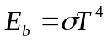 (1)
For a diffuse-gray surface (A), the net heat current that leaves is:
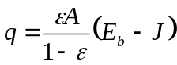 (2)
where A is the surface
ε is the surface emittance
J is the surface radiosity♥
The radiation heat exchange between two diffuse-gray infinite parallel plates become (Kirchoff law):
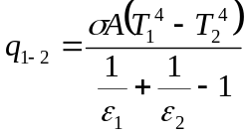 (3)
where A is the area of the plates (= A₁ = A₂)
In TYPE 56, the radiation heat transfer is modeled as an electrical resistance submitted to the difference of potential due to the difference of temperature between the two plates. So a radiative heat exchange coefficient is defined:
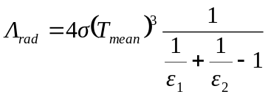 (4)
where 4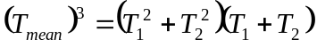 (5)
And the radiation heat exchange is proportional to:
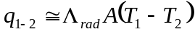 (6)
This way, it is possible to define a fictitious coefficient T_{meanNEW} which is the T_{mean} which is needed in the model in order to have the effect of a modification of the surface emittance:
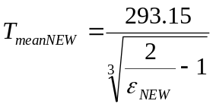 (7)
where ε_{NEW} is the required emittance.

Modeling Difficulties
It is also possible to change in good proportions the Stefan-Boltzmann constant in order to have the same effect. Nevertheless, we decided to avoid this possibility because we suspect another use of this constant in TYPE 56.
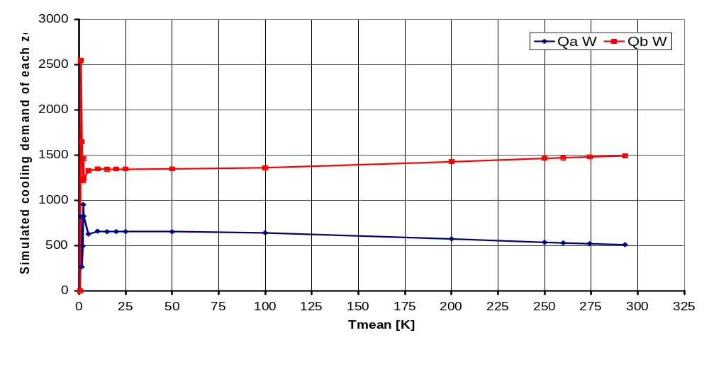
Figure 6 - Evolution of the simple two zone final solution with Tmean
Another possible way is to change the area A of the radiation wall. But, in this case, if we change the area of the wall, we change also the view factor between the emitter and the absorber.
Three cases were simulated. First, the model considered a mean temperature of surface (Tmean) equal to 293.15K That means that the emittance of the internal walls was 1. Then, Tmean was fixed to the lower value (near absolute zero) in order to approach an emittance close to zero. This value was chosen to 25K. Last, Tmean was fixed to 274.18K in order to create an effect of an emittance of 0.9.
In Figure 6, we see the evolution of the simple two zone solution calculated by TRNSYS 15 in function of Tmean. We observe that the solution is “stable” above 25K. Under 10K, the solution diverges because the inversion of the X matrix in the Seem method is impossible near 0K (see 2.2.2.). Some elements of this matrix have infinite values.

Software Errors Discovered and/or Comparison Between Different Versions of the Same Software
No other version of the software was tested.

Results

Simple formulation of the problems
The simulation results are presented in Table 1 (simple MZ200 & simple MZ210) and Table 2 (simple MZ300 & simple MZ310). The variables are :
- the wall surface temperatures,
- the air temperatures,
- the star network temperatures,
- the heat transfer resistances (equivalent, star network and conduction),
- the loads,
- the heat transfer coefficient between the zones
The two first columns (1,2) of each table are the results of the analytical solution. The next column (3) is the simulation results of the multizone problem without manipulation on the properties of the model (T_{mean}=293.15K, ε=1). The two last columns (4,5) are the simulation results of the multizone problem with the new parameter T_{meanNEW}. The emittance is tuned (ε=1.239e-3 and ε=0.9).
The elements in blue are post-simulation results.
In Table 1, the column 1 and the column 4 are not very different in this situation. T_{mean} was tuned in order to find the same loads as the analytical solution. The UA coefficients are the same. We compare the emittance calculated with the equation (7) to the emittance identified in the specifications. With T_{meanNEW}=25, we calculate an emittance of 0.001239 although very small. It is thousand times greater than the specified emittance (0.000001). This difference is due to the star network model itself. TYPE 56 calculates the inverse of the X matrix of the star network (see section 4). The mean relative error is about 0.01% on the load calculation.
The very little difference between the theorical and simulated equivalent resistances is due to the difference of emittance (0.000001 and 0.001239 (lowest emittance that could be imposed)). The radiative resistances are not exactly the same.
The columns 2 and 5 are a little more different. The UA coefficients are quite dissimilar. This is due to the differences between the theorical and “simulated” resistances (equivalent and star). Now, the theorical and simulated emittances are the same. So, the radiative resistances are also the same. This difference between the results couldn’t been explain by the numerical limitation of the software. Perhaps, this mistake is due to the different method to solve the inversion of the X matrix by Matlab (analytical solution) or by TYPE 56 (simulated solution). Matlab uses Laplack♦ functions to inverse. The method used by TYPE 56 is unknown because the user doesn’t get the Fortran source code. In this case, the mean relative error is about 1.09 % on the heat transfer coefficient (UA).
The similar remarks can be made for the three-zone simulation (see Table 2). The fourth column results have been calculated with T_{meanNEW}=25K, without tuning. So, we could estimate the validity of the software in this case. Without the radiative phenomena, the mean relative errors are about 0.02% on the load calculation and 0.06% on the zone C air temperature. With ε=0.9, the divergence between the theorical and simulated solutions is greater than in the two-zone problem. The mean relative error is about 4.23% on the zone C air temperature. This error stays tolerable.

Table 1 - MZ200 and MZ2100 results (simple formulation)

 |  |  | Analytical solution |  | 1 adiabatic surface of 21.6m² (VF = 1)
 | Variables | Units | MZ200 | MZ210 | TYPE 56 | TYPE 56 with TmeanNEW
 |  |  |  |  |  | Tmean = 25K | Tmean = 274.18K
 |  |  |  |  | ε=1 | ε=1.239e-3 | ε=0.9
Zone A | Ta | °C | 25.00 | 25.00 | 25.00 | 25.00 | 25.00
Zone A | Ta* | °C | 25.00 | 22.98 | 22.89 | 25.00 | 23.05
Zone A | T0 | °C | 25.00 | 22.98 | 22.89 | 25.00 | 23.05
Zone A | T1 | °C | 25.00 | 22.98 | 22.89 | 25.00 | 23.05
Zone A | T2 | °C | 21.00 | 21.40 | 21.42 | 21.00 | 21.39
Zone A | Ra* | °C/W | 0 | 0.004166 | 0.004296 | 0 | 0.004062
Zone A | R01 | °C/W | inf | inf | 7196.4 | 7196.4 | 7196.4
Zone A | Req,1a | °C/W | 0.011574 | 0.003241 | 0.003001 | 0.011554 | 0.003469
Zone A | Req,2a | °C/W | 0.011574 | 0.003241 | 0.003001 | 0.011554 | 0.003469
Zone A | QA | W | 654.4 | 514.6 | 508.9 | 654.5 | 519.9
Zone B | Tb | °C | 15.00 | 15.00 | 15.00 | 15.00 | 15.00
Zone B | Tb* | °C | 15.00 | 17.02 | 17.11 | 15.00 | 16.95
Zone B | T3 | °C | 19.00 | 18.60 | 18.58 | 19.00 | 18.61
Zone B | T4 | °C | 15.00 | 17.02 | 17.11 | 15.00 | 16.95
Zone B | T5 | °C | 15.00 | 17.02 | 17.11 | 15.00 | 16.95
Zone B | Rb* | °C/W | 0 | 0.004166 | 0.004296 | 0 | 0.004062
Zone B | Req,3b | °C/W | 0.011574 | 0.003241 | 0.003001 | 0.011554 | 0.003469
Zone B | Req,4b | °C/W | 0.011574 | 0.003241 | 0.003001 | 0.011554 | 0.003469
Zone B | R45 | °C/W | inf | inf | 7196.4 | 7196.4 | 7196.4
Zone B | QB | W | 1345.6 | 1485.4 | 1491.1 | 1345.5 | 1480.1
 | R23 | °C/W | 0.005787 | 0.005787 | 0.005787 | 0.005787 | 0.005787
 | UA | W/°C | 34.56 | 48.54 | 49.11 | 34.55 | 48.01
 | U | W/m².°C | 1.60 | 2.25 | 2.27 | 1.60 | 2.22
 | Qint | W | 1000 | 1000 | 1000 | 1000 | 1000
 | QTOT | W | 2000 | 2000 | 2000 | 2000 | 2000
 | QB-QA | W | 691.2 | 970.8 | 982.2 | 691.0 | 960.2
 | Linear = (dQAB)e=0.9 - (dQAB)e=0 / (dQAB)e=1 - (dQAB)e=0 |  |  |  |  |  | 0.924

Table 2 - MZ300 and MZ310 results (simple formulation)

 |  |  | Analytical solution |  | 1 adiabatic surface of 21.6m² (VF = 0.5 or 1)
 | Variables | Units | MZ300 Analytical solution | MZ310 Analytical solution | TYPE 56 | TYPE 56 with TmeanNEW
 |  |  |  |  |  | Tmean = 2.33K | Tmean = 274.18K
 |  |  |  |  | ε=1 | ε=1e-6 | ε=0.9
Zone A | Ta | °C | 25.00 | 25.00 | 25.00 | 25.00 | 25.00
Zone A | Ta* | °C | 25.00 | 25.78 | 25.57 | 25.00 | 25.59
Zone A | T0 | °C | 25.00 | 25.78 | 25.53 | 25.00 | 25.55
Zone A | T1 | °C | 25.00 | 25.78 | 25.57 | 25.00 | 25.59
Zone A | T2 | °C | 27.00 | 26.99 | 25.97 | 27.99 | 26.10
Zone A | Ra* | °C/W | 0 | 0.004166 | 0.004254 | 0 | 0.003986
Zone A | R01 | °C/W | inf | inf | 7196.4 | 7196.4 | 7196.4
Zone A | Req,1a | °C/W | 0.011574 | 0.003241 | 0.003001 | 0.011554 | 0.003469
Zone A | Req,2a | °C/W | 0.011574 | 0.003241 | 0.003001 | 0.011554 | 0.003469
Zone A | QA | W | 1259.2 | 1186.8 | 1134.0 | 1259.0 | 1148.0
Zone C | Tc | °C | 32.50 | 31.00 | 29.51 | 32.48 | 29.69
Zone C | Tc* | °C | 32.50 | 28.81 | 27.24 | 32.48 | 27.57
Zone C | T3 | °C | 28.50 | 28.07 | 26.75 | 29.49 | 26.95
Zone C | T4 | °C | 25.50 | 26.13 | 24.55 | 29.49 | 24.55
Zone C | T8 | °C | 32.50 | 31.00 | 27.24 | 32.48 | 27.27
Zone C | T9 | °C | 32.50 | 31.00 | 27.19 | 32.42 | 27.53
Zone C | Rc* | °C/W | 0 | 0.002540 | 0.002627 | 0 | 0.002454
Zone C | R89 | °C/W | inf | inf | 7196.4 | 7196.4 | 7196.4
Zone C | Req,3c | °C/W | 0.011574 | 0.003953 | 0.003683 | 0.011559 | 0.004205
Zone C | Req,4c | °C/W | 0.011574 | 0.003953 | 0.003683 | 0.011559 | 0.004205
Zone C | Req,8c | °C/W | 0.011574 | 0.003953 | 0.003683 | 0.011559 | 0.004205
Zone B | Tb | °C | 15.00 | 15.00 | 15.00 | 15.00 | 15.00
Zone B | Tb* | °C | 15.00 | 17.82 | 18.13 | 15.01 | 17.91
Zone B | T5 | °C | 22.00 | 22.21 | 20.32 | 21.99 | 20.40
Zone B | T6 | °C | 15.00 | 17.82 | 18.13 | 15.01 | 17.91
Zone B | T7 | °C | 15.00 | 17.82 | 18.10 | 15.00 | 17.88
Zone B | Rb* | °C/W | 0 | 0.004166 | 0.004288 | 0.000017 | 0.004053
Zone B | Req,5b | °C/W | 0.011574 | 0.003241 | 0.003001 | 0.011554 | 0.003469
Zone B | Req,6b | °C/W | 0.011574 | 0.003241 | 0.003001 | 0.011554 | 0.003469
Zone B | R67 | °C/W | inf | inf | 7196.4 | 7196.4 | 7196.4
Zone B | QB | W | 1604.8 | 1677.2 | 1730.0 | 1605.0 | 1718.0
 | R23 | °C/W | 0.005787 | 0.005787 | 0.005787 | 0.005787 | 0.005787
 | R45 | °C/W | 0.005787 | 0.005787 | 0.005787 | 0.005787 | 0.005787
 | UA (zone A) | W/°C | 34.56 | 31.11 | 29.71 | 34.63 | 31.56
 | U (zone A) | W/m².°C | 1.60 | 1.44 | 1.38 | 1.60 | 1.46
 | UA (zone B) | W/°C | 34.56 | 42.32 | 50.31 | 34.61 | 48.88
 | U (zone B) | W/m².°C | 1.60 | 1.96 | 2.33 | 1.60 | 2.26
 | Qint | W | 1000 | 1000 | 1000 | 1000 | 1000
 | QintC | W | 864 | 864 | 864 | 864 | 864
 | QTOT | W | 2864 | 2864 | 2864 | 2864 | 2866
 | (QC-QA)-(QC-QB) | W | 345.6 | 490.5 | 596.0 | 346.0 | 570.0
 | Linear = (dQ)e=0.9 - (dQ)e=0 / (dQ)e=1 - (dQ)e=0 |  |  |  |  |  | 0.896

Complex formulation of the problem
The simulation results are presented in Table 3. (complex MZ200 & complex MZ210) and (complex MZ300 & complex MZ310). The variables are :
- the wall surface temperatures,
- the air temperatures,
- the star network temperatures,
- the loads,
- the heat transfer coefficient between the zones
In the tables, we don’t have reported the analytical solutions of the simple formulation. Fr the reason that we don’t have evaluate the analytical solution of the complex formulation, finally no analytical solutions are reported in this section. Moreover, it isn’t necessary to compare and evaluate the performances of the simulation tool (TYPE 56) because good performances have been established if the paragraph above.
We see in the tables that all the surface temperatures of the adiabatic walls are closed to the same value: T* of the zone. That means that the balance of all the heat transfers between the star node and the surface nodes is null. We speak about “balance” because the absorbed heat (by radiation from common wall) is equal to the emitted heat (by convection to the air). The walls are completely adiabatic.
When the emittance is equal to zero, the global heat transfer coefficient between air nodes are the same in the four cases (simple or complex MZ200 and MZ210). This UA value is about 34.55 W/K .. 34.63 W/K. When we introduce the emittance in the calculation, The UA value is greater. The UA value could be evaluated as the sum of the UA value without radiation and a fraction (equal to the emittance of the wall surfaces) of the difference between UA value with emittance equal to 1 and UA value without radiation [5]:
(8)
At the bottom of each result table, we have calculate the emittance of the simulation according to this definition (see equation (8)):
= 0.924 for the simple MZ210 case
= 0.896 for the simple MZ310 case
= 0.871 for the complex MZ210 case
= 0.866 for the complex MZ310 case
We see that this approximation could be used in some rapid global heat balance in a zone if the calculation needs simplifications.
Table 3 - MZ200 and MZ210 results (complex formulation)

 |  |  | 6 surfaces per zone
 | Variables | Units | TYPE 56 | TYPE 56 with TmeanNEW
 | Variables | Units | TYPE 56 | Tmean = 25K | Tmean = 274.18K
 | Variables | Units | ε=1 | ε=1.239e-3 | ε=0.9
Zone A | Ta | °C | 25.00 | 25.00 | 25.00
Zone A | Ta* | °C | 24.41 | 25.00 | 24.49
Zone A | T2 | °C | 21.80 | 21.00 | 21.70
Zone A | T1,south | °C | 24.41 | 25.00 | 24.49
Zone A | T1,ceiling | °C | 24.41 | 25.00 | 24.49
Zone A | T1,floor | °C | 24.41 | 25.00 | 24.49
Zone A | T1,east | °C/W | 24.41 | 25.00 | 24.49
Zone A | T1,west | °C/W | 24.41 | 25.00 | 24.49
Zone A | QA | W | 378.4 | 654.7 | 413.6
Zone B | Tb | °C | 15.00 | 15.00 | 15.00
Zone B | Tb* | °C | 15.59 | 15.00 | 15.51
Zone B | T3 | °C | 18.20 | 19.00 | 18.30
Zone B | T4,north | °C | 15.59 | 15.00 | 15.51
Zone B | T4,ceiling | °C | 15.59 | 15.00 | 15.51
Zone B | T4,floor | °C | 15.59 | 15.00 | 15.51
Zone B | T4,east | °C/W | 15.59 | 15.00 | 15.51
Zone B | T4,west | °C/W | 15.59 | 15.00 | 15.51
Zone B | QB | W | 1622.0 | 1347.0 | 1586.0
 | UA | W/°C | 62.18 | 34.62 | 58.62
 | U | W/m².°C | 2.88 | 1.60 | 2.71
 | Qint | W | 1000 | 1000 | 1000
 | QTOT | W | 2000.4 | 2001.7 | 1999.6
 | QB-QA | W | 1243.6 | 692.3 | 1172.4
 | Linear = (dQAB)e=0.9 - (dQAB)e=0 / (dQAB)e=1 - (dQAB)e=0 |  |  |  | 0.871

Table 4 - MZ300 and MZ310 results (complex formulation)

 |  |  | 6 surfaces per zone
 | Variables | Units | TYPE 56 | TYPE 56 with TmeanNEW
 | Variables | Units | TYPE 56 | Tmean = 2.33K | Tmean = 274.18K
 | Variables | Units | ε=1 | ε=1e-6 | ε=0.9
Zone A | Ta | °C | 25.00 | 25.00 | 25.00
Zone A | Ta* | °C | 25.10 | 25.00 | 25.11
Zone A | T2 | °C | 25.52 | 28.01 | 25.69
Zone A | T1,south | °C | 25.10 | 25.00 | 25.11
Zone A | T1,ceiling | °C | 25.10 | 25.00 | 25.11
Zone A | T1,floor | °C | 25.10 | 25.00 | 25.11
Zone A | T1,east | °C/W | 25.10 | 25.00 | 25.11
Zone A | T1,west | °C/W | 25.10 | 25.00 | 25.11
Zone A | QA | W | 1102.0 | 1261.0 | 1123.0
Zone C | Tc | °C | 27.36 | 32.53 | 27.75
Zone C | Tc* | °C | 26.54 | 32.53 | 26.99
Zone C | T3 | °C | 26.11 | 29.52 | 26.40
Zone C | T4 | °C | 23.34 | 25.52 | 23.46
Zone C | T8_ceiling | °C | 26.54 | 32.53 | 26.99
Zone C | T8_floor | °C | 26.54 | 32.53 | 26.99
Zone C | T8_east | °C/W | 26.54 | 32.53 | 26.99
Zone C | T8_west | °C/W | 26.54 | 32.53 | 26.99
Zone B | Tb | °C | 15.00 | 15.00 | 15.00
Zone B | Tb* | °C | 15.72 | 15.00 | 15.65
Zone B | T5 | °C | 18.93 | 22.01 | 19.17
Zone B | T6_north | °C | 15.72 | 15.00 | 15.65
Zone B | T6_ceiling | °C | 15.72 | 15.00 | 15.65
Zone B | T6_floor | °C/W | 15.72 | 15.00 | 15.65
Zone B | T6_east | °C/W | 15.72 | 15.00 | 15.65
Zone B | T6_west | °C/W | 15.72 | 15.00 | 15.65
Zone B | QB | W | 1762.0 | 1607.0 | 1741.0
 | UA (zone A) | W/°C | 43.22 | 34.66 | 44.73
 | U (zone A) | W/m².°C | 2.00 | 1.60 | 2.07
 | UA (zone B) | W/°C | 61.65 | 34.63 | 58.12
 | U (zone B) | W/m².°C | 2.85 | 1.60 | 2.69
 | Qint | W | 1000 | 1000 | 1000
 | QintC | W | 864 | 864 | 864
 | QTOT | W | 2864 | 2868 | 2864
 | (QC-QA)-(QC-QB) | W | 660.0 | 346.0 | 618.0
 | Linear = (dQ)e=0.9 - (dQ)e=0 / (dQ)e=1 - (dQ)e=0 |  |  |  | 0.866

Other Results

Impact of the view factor
The complex two-zone problem is defined with 11 walls: each zone is defined with 5 adiabatic walls and 1 is common to both zones. The geometry of the problem must be taken into account. We need to introduce the definition of the view factors to approximate the reality. In Figure 7, the view factor between two surfaces (A₁ and A₂) is illustrated. The view factor based on A₁ is defined as:
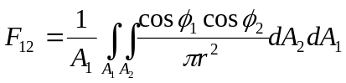 (9)
and the view factor on A₂ is defined is defined:
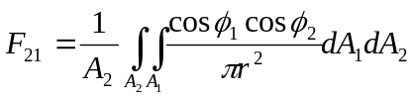 (10)
The net heat transfer rate from A1 to A2 is now given by the expression:
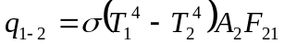 (11)
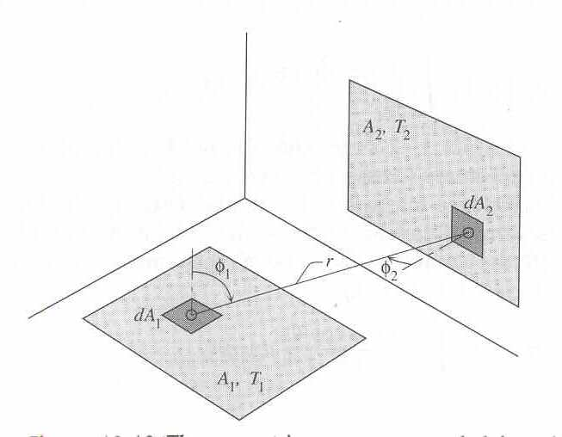
Figure 7 - Illustration of the view factor concept
The analytical resolution becomes very complicated. The network of convection and radiative resistances and temperature nodes is complex. Indeed, the elements in the X matrix (in Seem method) are different and the resolution needs more working time.
With TRNSYS and Type 56, it is not possible to introduce the geometrical configuration. The user can only introduce the composition and the area of the walls. The user can also introduce the connections between surfaces through which the heat is exchanged. The calculation of the view factors with TYPE 56 is based on the surface area ratio, only.
The comparison between the analytical method and the TYPE 56 method to calculate the view factors is presented in Table 5. The evaluation of the “analytical” view factors have been short-cut using the Figure 8 and Figure 9. The precision of the values isn’t optimal. The view factors (calculated with the two methods) for the parallel surfaces are equal. The view factors for the orthogonal surfaces are different. The sum of the view factors calculated by TYPE 56 is equal to 1, not the sum of the view factors evaluated analytically. This observations means that TYPE 56 method doesn’t take into account the angular distribution of the view factor in space. The fraction of the view factor calculated for the part of the surface which is in contact with an adjacent orthogonal surface is insignificant. This is the “edge or boundary effect”. TYPE 56 doesn’t include this phenomena in the calculation.

Table 5 - Comparison between the view factor calculation methods
 |  | Surfaces | Analytical | TYPE 56 | X/H - H/X | Y/H - Y/X | Area
 |  | Surfaces | [-] | [-] | [-] | [-] | [m²]
Zone A |  | South | ~ 0.14 | 0.14 | 1.33 | 0.45 | 21.6
Zone A |  | Ceiling | ~ 0.15 | 0.32 | 0.34 | 0.75 | 48
Zone A |  | Floor
Zone A |  | East | ~ 0.17 | 0.11 | 2.96 | 2.22 | 16.2
Zone A |  | West
 |  | Total | ~ 0.78 | 1.00

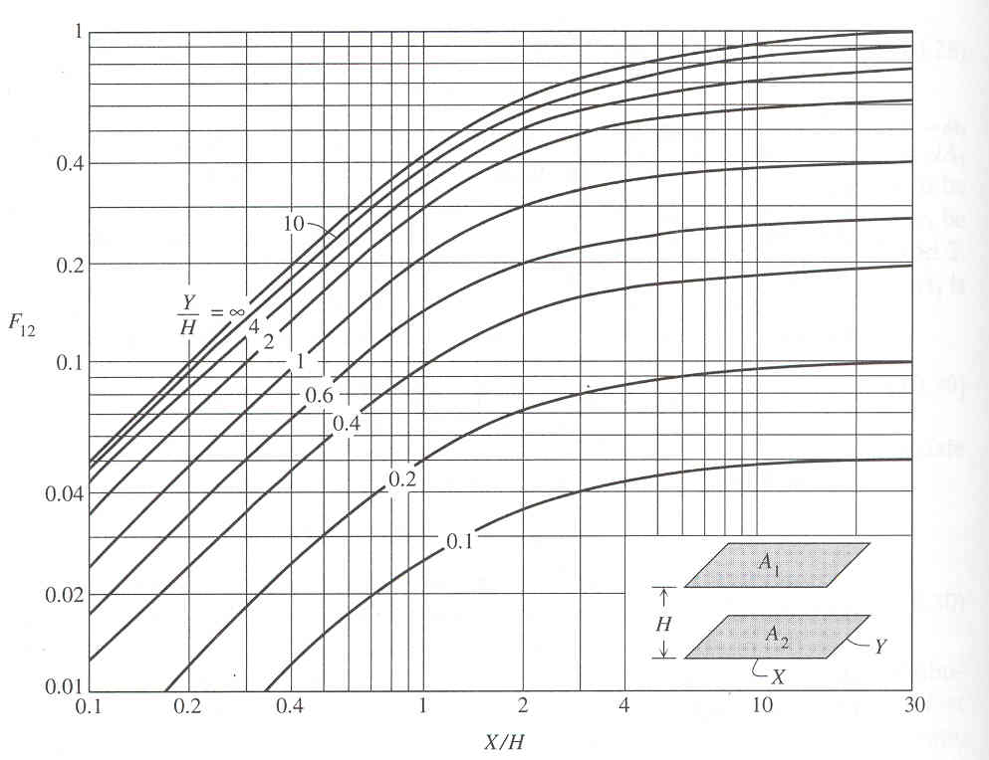
Figure 8 - The geometric view factor between two parallel rectangles

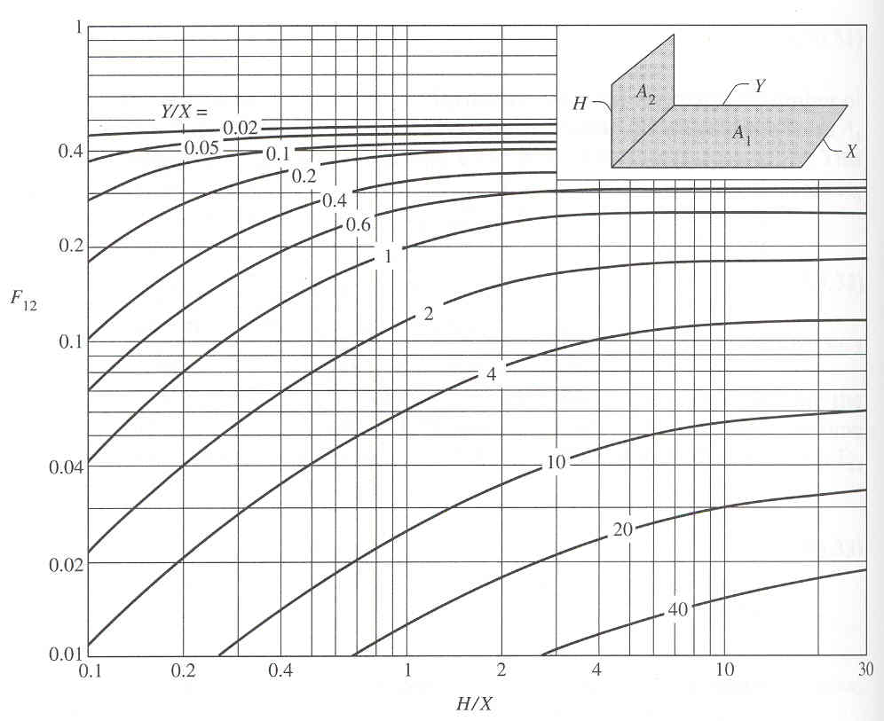
Figure 9 - The geometric view factor between two perpendicular rectangles with a common edge

Conclusions and Recommendations
TRNSYS (TYPE 56) is a very powerful software to solve building problems. It calculates the heat transfer by conduction into the walls, by convection between walls and air and by radiation between wall surfaces. The number of walls is not a problem.
The developers have limited the software to the resolution of generic problems with wall emittance equal to one and without geometrical description. But, the software calculates approximate view factors. We note that the window emittance is well-defined.
In future version of TRNSYS (TRNSYS 16), PREBID is renamed TRNBuild. TRNBuild will be more efficient. The wall emittance should be defined but only for back (outside) surface of external walls.
The proposed theorical solution (in cases of ε=0.9) is not clear. There is no calculation and no more explanations. Where does the “5.13W/m².K” come from ? The calculation of the combination of convective and radiative surface heat transfer coefficient for the internal wall is not full of convenience.

References
- Solar energy laboratory - March 2000 - TRNSYS 15, A Transient System Simulation Program - Solar energy laboratory, University of Wisconsin (Madison), Madison WI 53706 USA.
- Adrian Bejan - 1993 - Heat Transfer. - John Wiley & Sons, Inc. - Chapter 10 RADIATION.
- John Ervin Seem - 1987 - Modeling of heat transfer in building - A thesis submitted in partial fulfillment of the requirements for the degree of Doctor of Philosophy (Mechanical Engineering) at the University of Wisconsin-Madison.
- Matlab ver. 6.5 Release 13 – Copyright 1984-2002, The MathWorks, Inc.
- ASHRAE 1997 - Energy Estimation and Modeling Methods - Fundamentals 30

Annex
Listing: MZ300.m

% ================================
% MZ310 Theorical solution by SEEM
% ================================

% Parameters
E=0.9;
s=5.669e-8;
Tmean=293.15;
Qint=1000;
QintC=864;
Ta=25;
Tb=15;
FF=0.5;

% Real resistances
Rconv=0.25/21.6;
Rrad=1/(FF*E*21.6*1*s*4*Tmean*Tmean*Tmean);
Rrad2=1/(E*21.6*1*s*4*Tmean*Tmean*Tmean);
Rcond=0.125/21.6;

% ================================
% Star network formulation by SEEM
% ================================

% Calcul of the resistances when one node is floating (X.Y=Z)
% X = [ -2/Rrad-1/Rconv 1/Rrad 1/Rrad 0 ]
% [ 1/Rrad -2/Rrad-1/Rconv 1/Rrad 0 ]
% [ 1/Rrad 1/Rrad -2/Rrad-1/Rconv 0 ]
% [ 1/Rconv 1/Rconv 1/Rconv -1 ]
% Y = [ T1-Tr ]
% [ T2-Tr ]
% [ T3-Tr ]
% [ qload ]
% Z = [ -q1 ]
% [ -q2 ]
% [ -q3 ]
% [ 0 ]
X=[[-2/Rrad-1/Rconv 1/Rrad 1/Rrad 0];[1/Rrad -2/Rrad-1/Rconv 1/Rrad 0];...
[1/Rrad 1/Rrad -2/Rrad-1/Rconv 0];[1/Rconv 1/Rconv 1/Rconv -1]];
Xinv=inv(X);

R12=Xinv(1,2)+Xinv(2,1)-Xinv(1,1)-Xinv(2,2);
R13=Xinv(1,3)+Xinv(3,1)-Xinv(1,1)-Xinv(3,3);
R23=Xinv(2,3)+Xinv(3,2)-Xinv(2,2)-Xinv(3,3);

R1r=-Xinv(1,1);
R2r=-Xinv(2,2);
R3r=-Xinv(3,3);

% Calcul of the resistance between Tr and T*
R= ( (R1r+R2r-R12)/(R12*R12*R12) + (R1r+R3r-R13)/(R13*R13*R13) + (R2r+R3r-R23)/(R23*R23*R23) ) /...
( 2*( 1/(R12*R12*R12) + 1/(R13*R13*R13) + 1/(R23*R23*R23) ) );

% Calcul of the equivalent resistances
%R1=R1r-R;
%R2=R2r-R;
%R3=R3r-R;

% ====================
% Application to MZ310
% ====================

RaS=Rconv*Rconv/(2*Rconv+Rrad2);
R2 =Rconv*Rrad /(2*Rconv+Rrad2);
R3 =R1r-R;
RcS=R;
R4 =R3;
R5 =R2;
RbS=RaS;
R23=Rcond;
R45=Rcond;

Ra=RaS+R2+R23+R3;
Rb=RbS+R5+R45+R4;

TcS=(Ra*Rb*QintC+Rb*Ta+Ra*Tb)/(Ra+Rb);
Tc=TcS+QintC*RcS;

QintA=(TcS-Ta)/Ra;
QintB=(TcS-Tb)/Rb;

Q=QintA+QintB;

T3=TcS-QintA*R3;
T2=T3-QintA*R23;
TaS=T2-QintA*R2;
Qa=QintA+Qint;

T4=TcS-QintB*R4;
T5=T4-QintB*R45;
TbS=T5-QintB*R5;
Qb=QintB+Qint;

% Verification
Ta=TaS-QintA*RaS;
Tb=TbS-QintB*RbS;

▪ This value corresponds to a radiation heat transfer coefficient of 5.14W/K.m². This value is identical to the surface coefficient which is proposed in the specifications.
✦ The long-wave radiation exchange between the surfaces within the zone and the convective heat flux from the inside surfaces to the zone air are approximated using the star network. This method uses an artificial temperature node (T_{star}) to consider the parallel energy flow from a wall surface by convection to the air node and by radiation to other wall and window elements.
 The total one-way heat flux that departs from A represents the surface radiosity and is labeled J (W/m²) (see [2] page 543).
◻ LAPACK is a large, multiauthor Fortran subroutine library that MATLAB uses for numerical linear algebra.

